sudo apt-get install ros-noetic-octomap

sudo apt-get install ros-noetic-octomap-mapping

sudo apt-get install ros-noetic-octomap-msgs ros-noetic-octomap-ros ros-noetic-rviz-plugins ros-noetic-octomap-server

#include <octomap/octomap.h>

#include <octomap/OcTree.h>

using namespace std;

using namespace octomap;

void print_query_info(point3d query, OcTreeNode *node)

{

if (node != NULL)

{

cout << "occupancy probability at " << query << ":\t " << node->getOccupancy() << endl;

}

else

cout << "occupancy probability at " << query << ":\t is unknown" << endl;

}

int main(int argc, char **argv)

{

cout << endl;

cout << "generating example map" << endl;

OcTree tree(0.1); // create empty tree with resolution 0.1

// insert some measurements of occupied cells

for (int x = -20; x < 20; x++)

{

for (int y = -20; y < 20; y++)

{

for (int z = -20; z < 20; z++)

{

point3d endpoint((float)x * 0.05f, (float)y * 0.05f, (float)z * 0.05f);

tree.updateNode(endpoint, true); // integrate 'occupied' measurement

}

}

}

// insert some measurements of free cells

for (int x = -30; x < 30; x++)

{

for (int y = -30; y < 30; y++)

{

for (int z = -30; z < 30; z++)

{

point3d endpoint((float)x * 0.02f - 1.0f, (float)y * 0.02f - 1.0f, (float)z * 0.02f - 1.0f);

tree.updateNode(endpoint, false); // integrate 'free' measurement

}

}

}

cout << endl;

cout << "performing some queries:" << endl;

point3d query(0., 0., 0.);

OcTreeNode *result = tree.search(query);

print_query_info(query, result);

query = point3d(-1., -1., -1.);

result = tree.search(query);

print_query_info(query, result);

query = point3d(1., 1., 1.);

result = tree.search(query);

print_query_info(query, result);

cout << endl;

tree.writeBinary("simple_tree.bt");

cout << "wrote example file simple_tree.bt" << endl

<< endl;

cout << "now you can use octovis to visualize: octovis simple_tree.bt" << endl;

cout << "Hint: hit 'F'-key in viewer to see the freespace" << endl

<< endl;

}

**aswath@aswath-ROG-Zephyrus-G15-GA502IV**:**~**$ sudo apt-get install ros-noetic-octovis

**aswath@aswath-ROG-Zephyrus-G15-GA502IV**:**~/Capstone_Project/catkin_ws/src/build/devel/lib/nxtbot**$ octovis ./simple_tree.bt

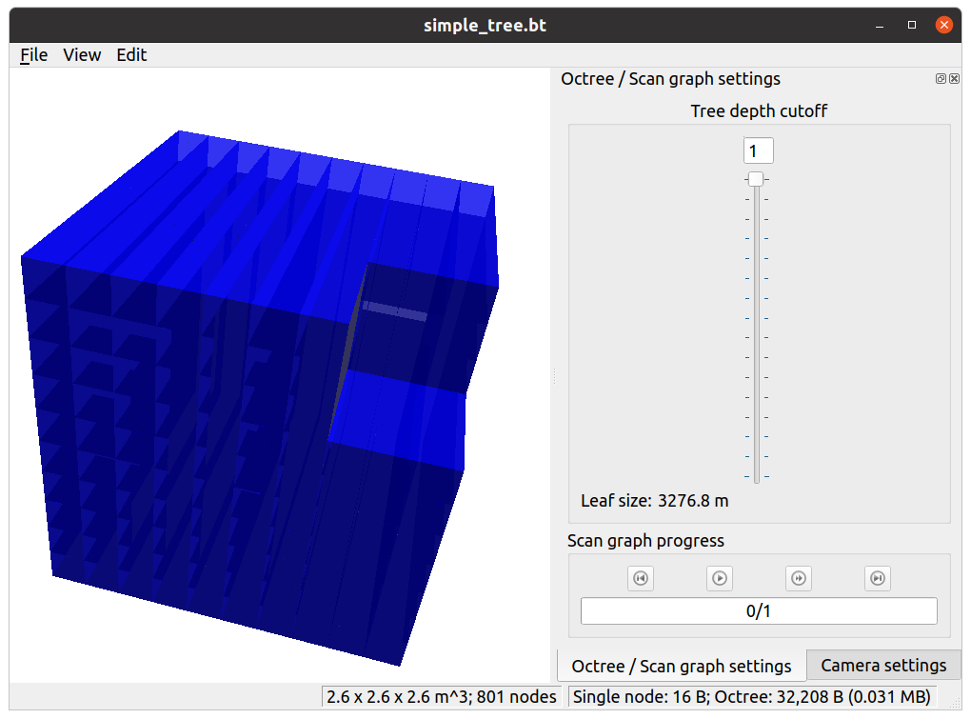

**aswath@aswath-ROG-Zephyrus-G15-GA502IV**:**~**$ sudo apt-get install ros-noetic-octomap-rviz-plugins

#include <octomap_msgs/conversions.h>

#include <octomap_ros/conversions.h>

Very imp for conversion from OCTree to Octomap messages

Needed for this : if(octomap_msgs::**binaryMapToMsg**(tree, octomap)){

tree.**writeBinary**("simple_tree.bt");

ERROR: Filestream to simple_tree.bt not open, nothing written.

Requires sudo to write to disk. i.e. sudo ./octomap_trial

ALWAYS CLEAN your workspace, even if your build, your old executable might run.

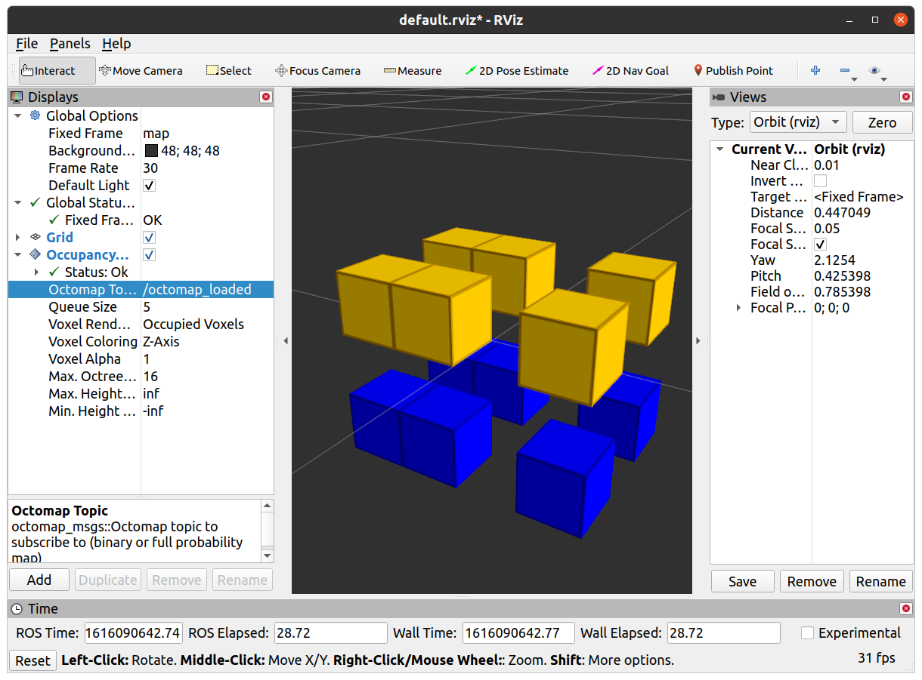

http://wiki.ros.org/cv_bridge/Tutorials/UsingCvBridgeToConvertBetweenROSImagesAndOpenCVImages#:~:text=conjunction%20with%20OpenCV.-,CvBridge%20is%20a%20ROS%20library%20that%20provides%20an%20interface%20between,OpenCVcv%3A%3AMat%20format.